1. 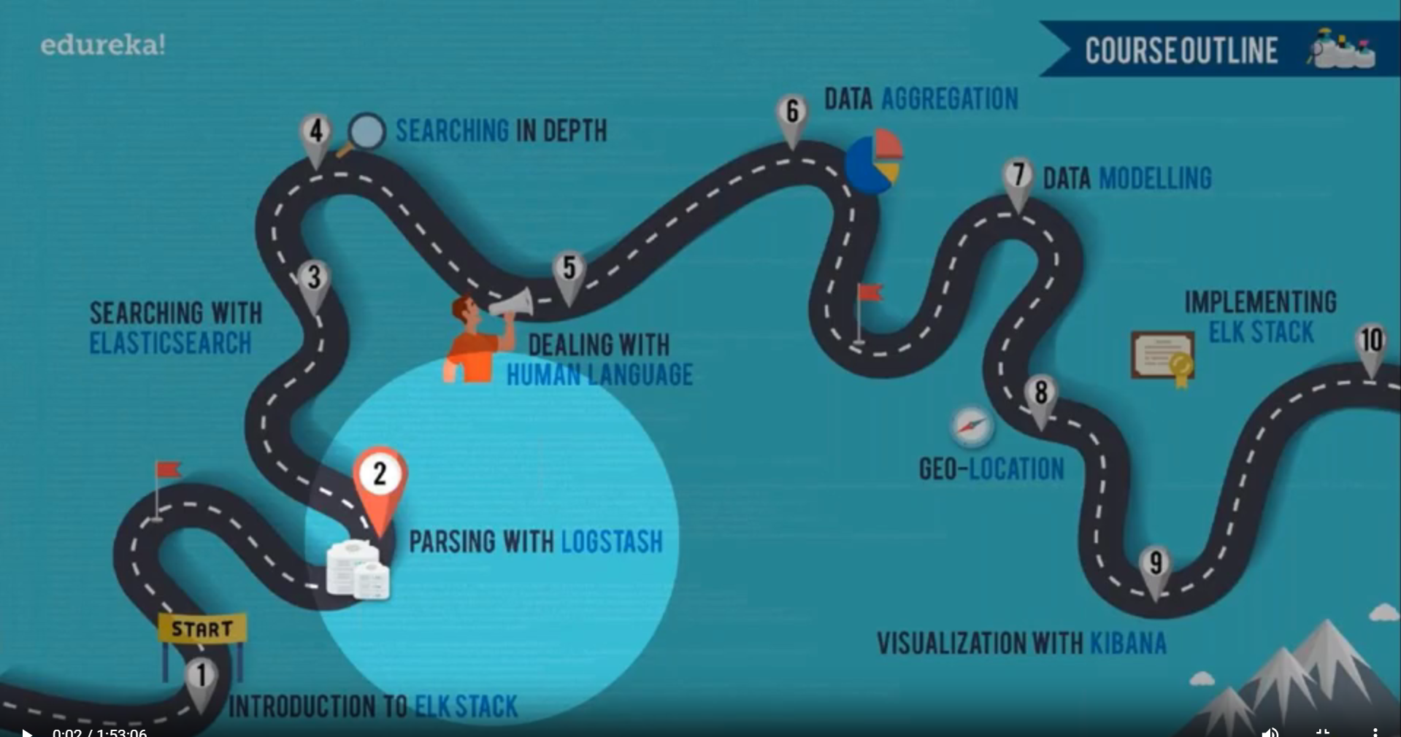
2. 
3. Objectives of Today Lecture:
   1. What is Logstash?
   2. What is the use of Logstash?
   3. Architecture of Logstash.
   4. How Logstash ingests data from various sources and how it processes?
   5. How to stash an event in Logstash?
   6. Various situations when Logstash unable to deliver the events.
   7. Transformation.
   8. Various Plugins.
   9. Benefits of using Filebeat along with Logstash.  
        
      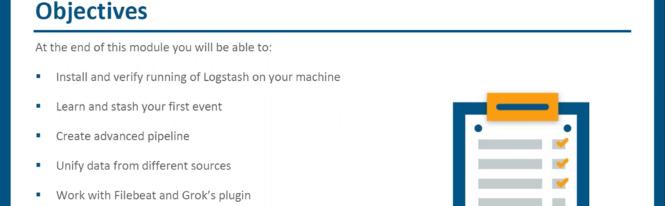
4. The lecture up to 18:05 was skipped. Please complete
5. 
6. 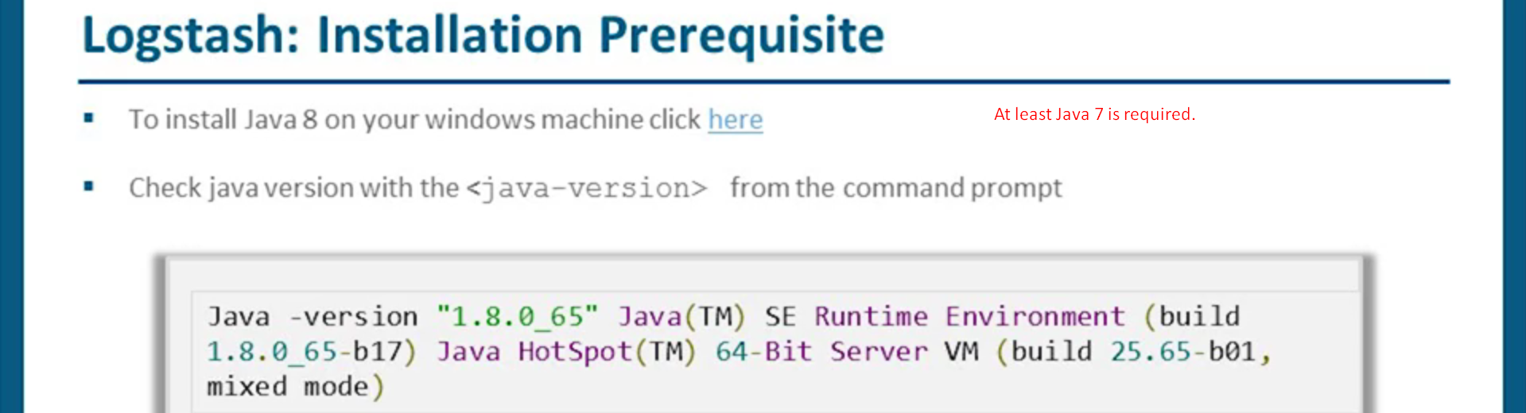
7. 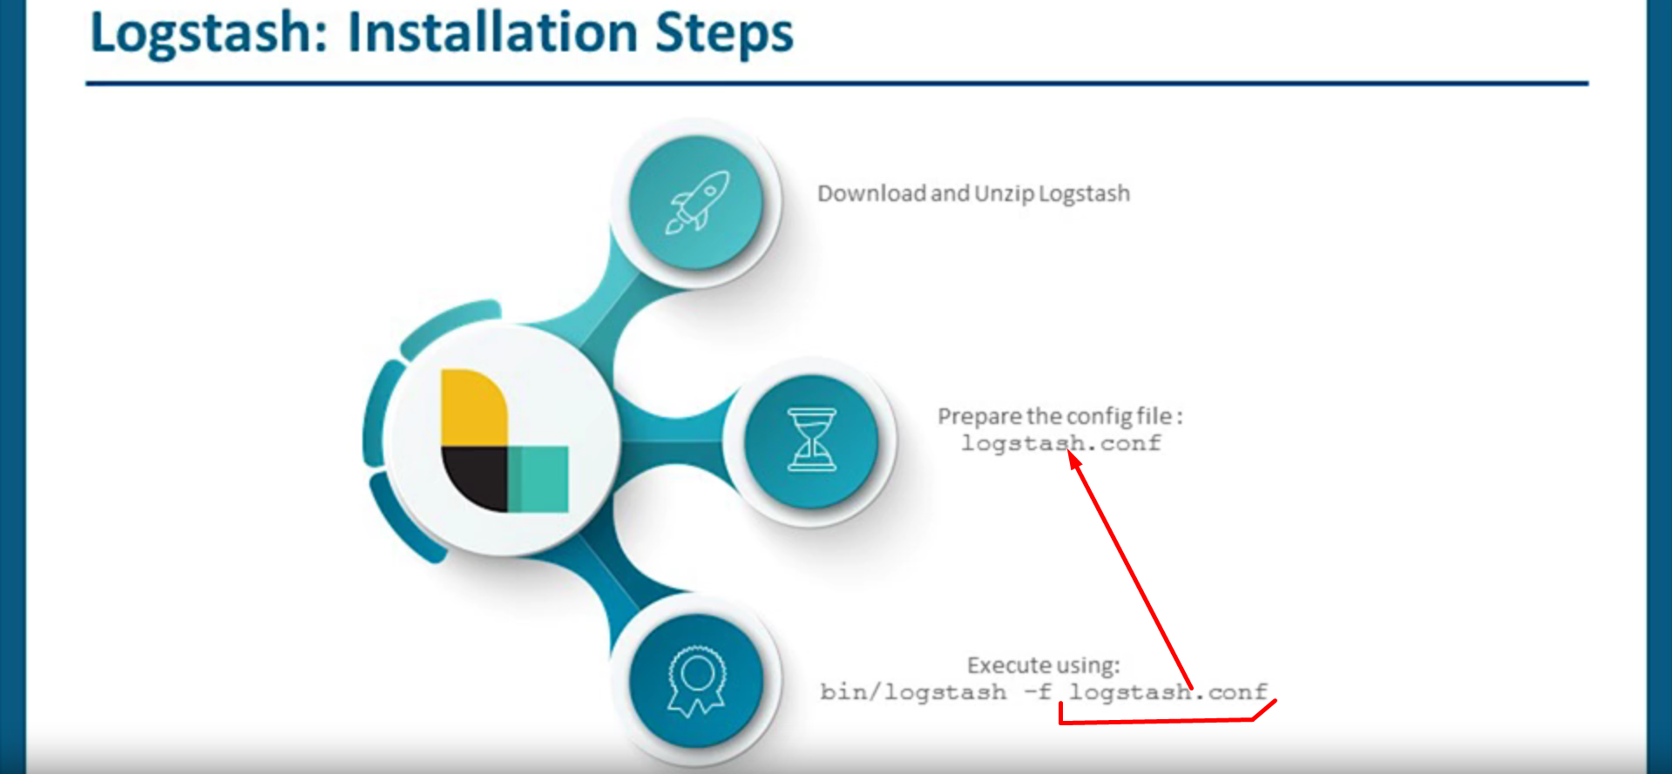
8. 
9. 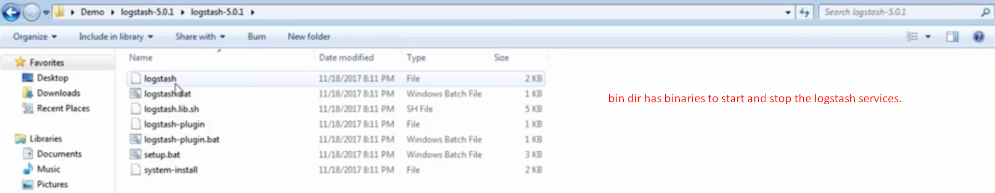
10. **logtash-5.0.1/config** directory.  
    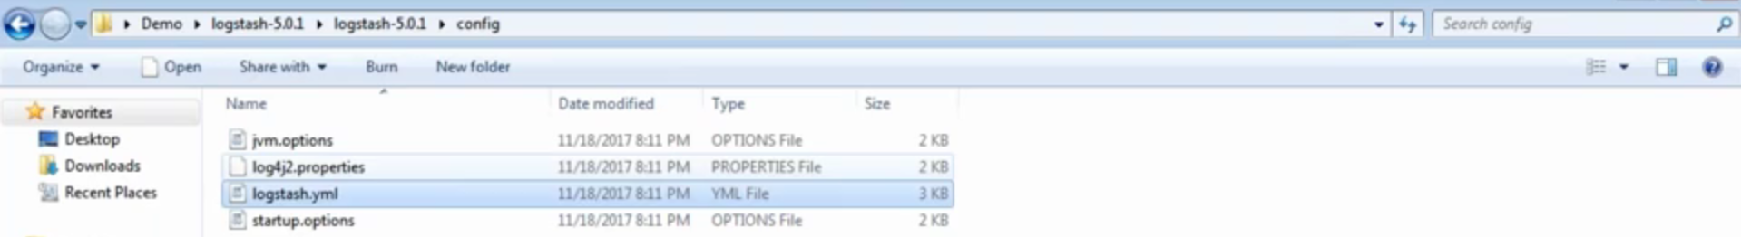  
      
      
    Following file -> **jvm.options** to configure JVM related properties like heap min, max size, CG Configurations etc.  
      
    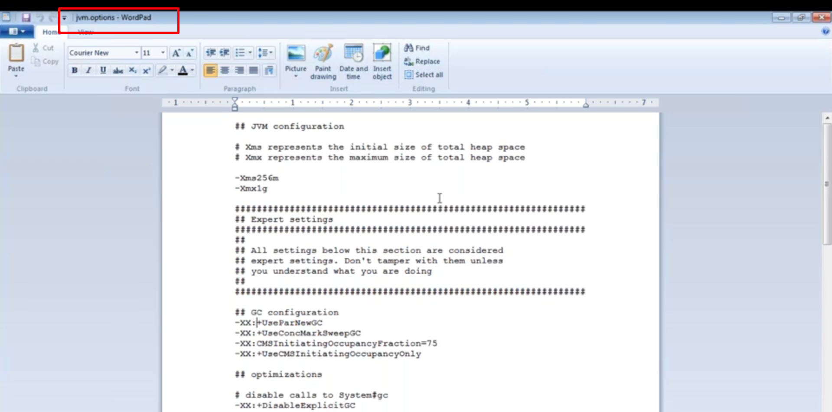
11. 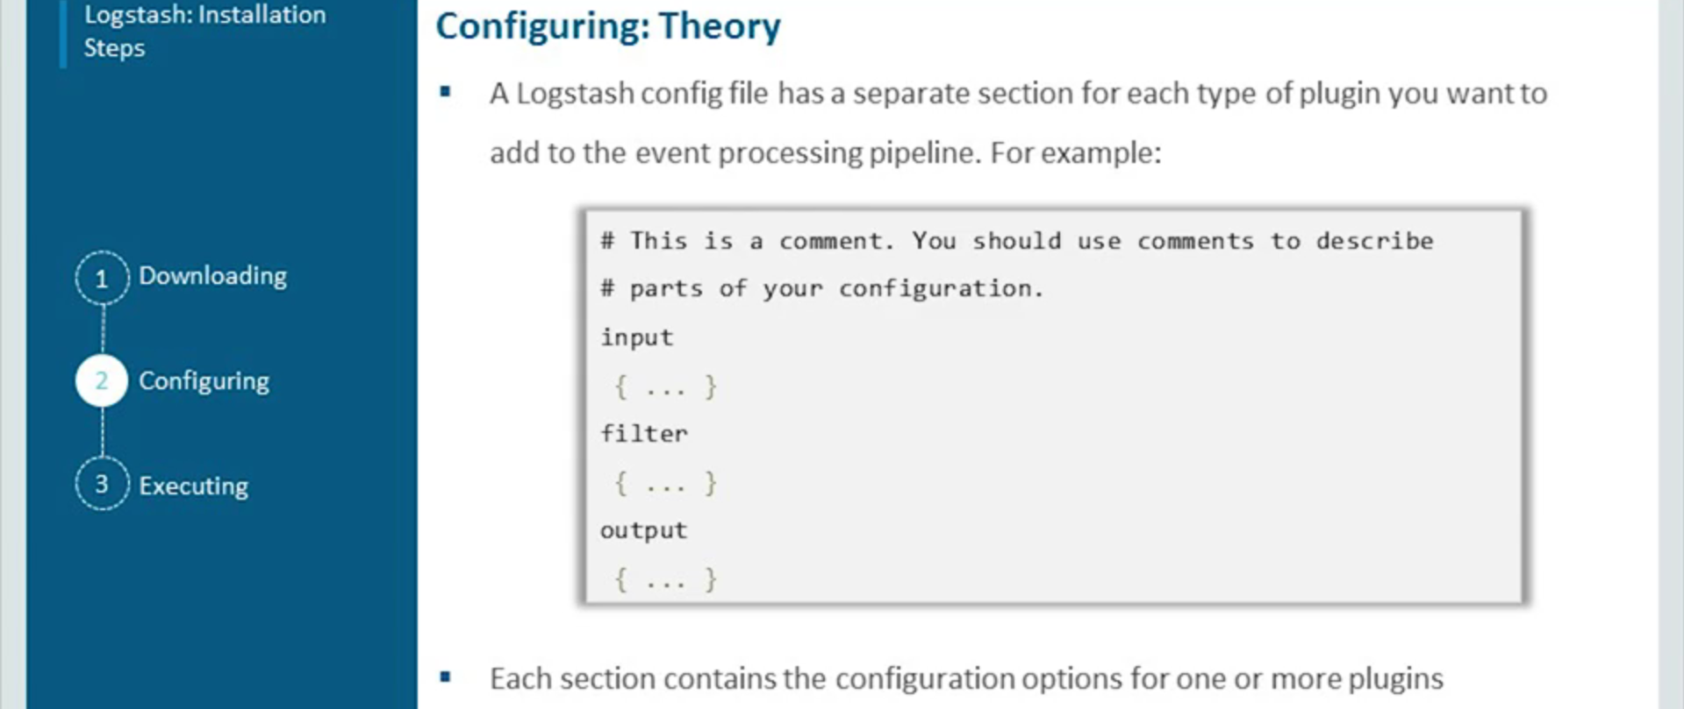
12. 